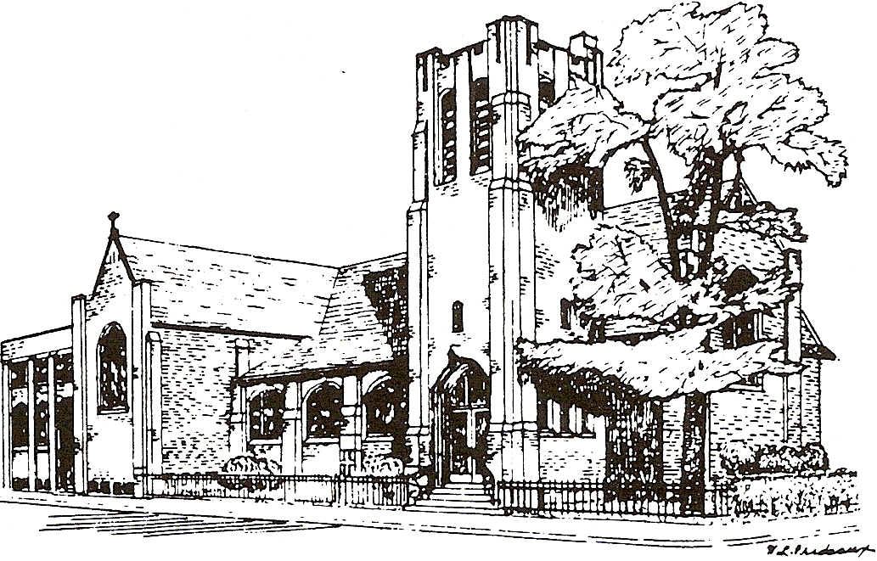
ST. BARNABAS ON THE DANFORTH ANGLICAN CHURCH
www.stbarnabas-toronto.com
361 Danforth Avenue,
Toronto, Ontario M4K 1Pl
416-463-1343

Notice to our Neighbours

St Barnabas prays that you have gotten through this pandemic and we look forward to re-entering a near normal lifestyle once again with stores and services reopening.

As a lot of you will know all public buildings need to be accessible by the end of this year. While we do have the lift at the south end of our building, you have to go through numerous spaces within the church which are most often occupied by others. Also to use the lift someone has to request it and a volunteer needs to get the key and operate it for them.

We have been planning to build a ramp along the side of the building on
Hampton for 4 yrs. We are pleased to announce that we have finally received all the approvals necessary and work will begin on its construction on Monday July 5th.

Unfortunately, this will mean a bit of a disruption at times along Hampton. Construction will most probably start early in the morning during the week. In order to help the Day Care, work that needs to take place in the playground area will happen on the weekends but this is minimal.

Construction will start with the removal of the metal fence and a couple of trees on the Hampton side yard. The very large tree at the corner of Danforth & Hampton is being protected and will remain in place. They will be cutting through the wall to make a new doorway for entry into the church at the very north end of the Hampton side of the building. Once that has been completed then the ramp construction will happen. We will also be moving the garbage and stroller storage into city-approved areas of the property.

We know that any construction in the downtown area often causes significant problems, including parking and traffic flow. We have taken every step we know of to make sure that we cut this down to as little as possible.

If you want to follow the construction progress, we will have notices and pictures on our website listed on the letterhead. We will be sending out notices to keep you informed as we reach milestones in the construction and thank you for your patience for this period of time that is needed to make our place of worship accessible to all.

We as a church will be offering services on Sundays at 10:30 with Communion of wafers only beginning on July 11th. We will most probably not be offering our 9am service on Sunday or our 11am service on Thursdays until at least the fall.

Stay well and stay safe. Rev Jeanette Lewis, Incumbent
on behalf of all parishioners at St Barnabas on the Danforth Anglican Church.

